
Internews has conducted the first assessment of the reach of existing Afghan broadcast media. Using the estimates of station managers from every radio station across the country, Internews has created a footprint of the maximum possible listenership figures of the state and independent stations.

Internews Radio Summary 2003

Total population estimate: grand figure and explanation of methodology

As a national figure it was found that an estimated maximum of 7.5million Afghans, or 37% of the population, have access to local radio broadcasts.

In calculating this figure, Internews used information provided by the UN Information Service AIMS. The figures for 2002-2003 estimate the total population of Afghanistan to be 20,055,983. The report breaks this total down, giving a figure for each of the 320 districts in the country.

At an Internews meeting, station managers were asked, based on their local knowledge of how far their broadcast signal reaches, to draw their coverage footprints onto maps. The number of villages in the designated area was then counted. Using this figure as a proportion of the total number of villages in the district, potential listenership figures were calculated for each station. By counting villages as opposed to simply calculating area, varying population densities were taken into account.

This figure does not however take into account the percentage who may not own a radio. Many women also have difficulty accessing programs; listening to the radio is commonly a male-dominated activity. State stations often broadcast for only a few hours a day, at a time that may not be convenient for some listeners. Taking these factors alone into account brings a realistic estimate well below 37% of the population.

Rural-Urban Considerations

The figures show a huge disparity between rural and urban access to radio. In the urban areas of Kabul, Kandahar, Herat, Jelalabad and Balkh there is easy access to radio, though outside of Kabul and there is only one Afghan broadcaster in each of these cities. However, if the above five urban centres are removed from the equation, access figures in rural areas are considerably lower. In a total rural population of 16.3 million, 3.9 million people, or 24% of the population, are within a local radio footprint.

National Map
Showing approximate station footprints for existing broadcasters.
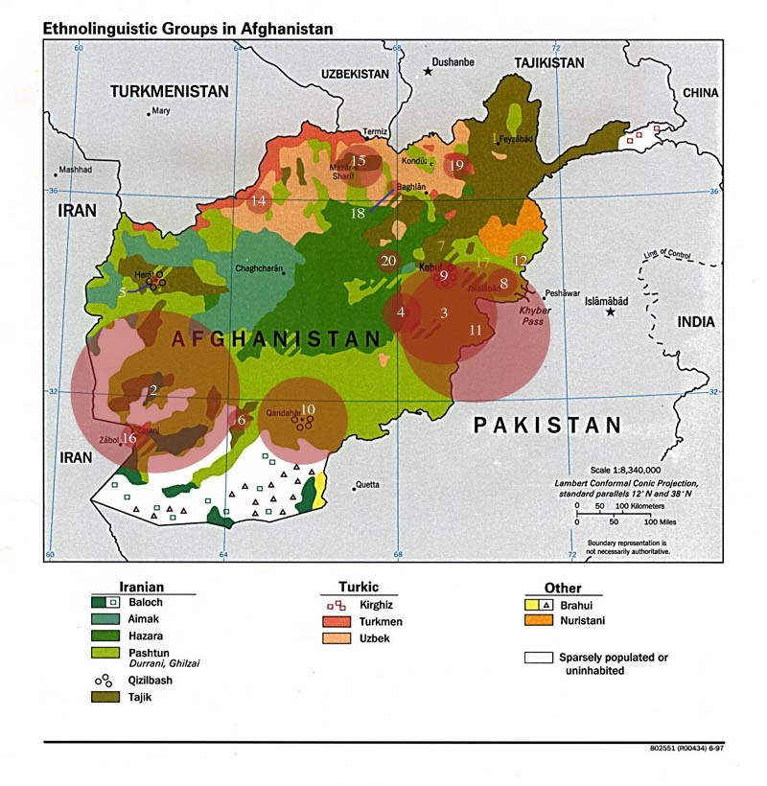Key:
- TV Badakhshan 11. Radio & TV Khost
- Radio Farah 12. Radio Kunar
- Radio Paktia 14. Radio Faryab
- Radio Ghazni 15. Radio & TV Balkh
- Radio & TV Herat 16. Radio & TV Nimroz
- Radio Helmand 17. Radio Laghman
- Radio Sada-I Solh 18. Radio Samangan
- Radio Nangarhar 19. Radio & TV Takhar
- Radio & TV Afghanistan 20. Radio Bamiyan
- Radio & TV Kandahar

Breakdown of figures per station

City | Radio Station | Radio footprint
Asad Abad | Radio Kunar | 70874
Aybak | Radio & TV Samangan | 39445
Chaghcharan | Radio Ghor | 3405
Faizabad | TV Badakhshan | 7776
Farah | Radio Farah | 212368
Ghazni | Radio Ghazni | 247293
Heart | Radio & TV Heart | 545276
Jalalabad | TV & Radio Nangarhar | 435613
Kabul | Radio Kabul & TV Afghanistan | 2677600
Khost | Radio Khost | 7766
Kandahar | Radio & TV Kandahar | 874600
Kunduz | TV Kunduz | 100000
Lashkar Ga | Radio Helmand | 280750
Mazar-e-Sharif | Radio & TV Balkh | 943800
Maimana City | Radio Faryab | 510913
Pulkhumri | Baghlan TV | 143300
Sherbhghan | Jawzjan TV | 186686
Taloqan | Radio & TV Takhar | 37928
Zaranj | Radio & TV Nimroz | 140502
 |  | 7465895

Plans for Expansion of National Radio

Within the next year, Internews is supporting the launch of 14 new radio stations across the country. These new stations are intended to supplement the existing network, as opposed to compete with it, in order to significantly increase the percentage of Afghans, with access to radio programming. IMPACS is launching a further 4 stations, bringing the total to 20 new stations. It is predicted that the percentage of the rural population with access to radio - currently only 24% - will more double over the next year, making radio by far the most effective mass medium for communication in Afghanistan.

